

Date as Postmark

Dear Applicant,

Thank you for the interest you have shown in joining PACSO in the role of **Playworker**. PACSO is a charity providing play and social opportunities for children with additional needs and their siblings. We currently offer Saturday Clubs once a month, Play Days at Easter and Christmas, a 2 week Playscheme and group trips in the summer holidays and after school clubs in term time. All our events and training are held at Chichester Nursery School, Children & Family Centre and Fordwater School.

Enclosed are all the forms you will need to fill out in order to become part of the PACSO team. Please find enclosed:

* Job Description & Playworker Requirements
* Application Form
* Medical Emergency Form
* P46 & Bank Details
* HMRC Starter Info
* DBS instructions
* Welcome Pack

Please complete all the forms and return them to us. I text staff about forthcoming club dates and times, and all you have to do is text me back to let me know if you are available to help.

Please don’t hesitate to call should you require more information. It would be great to have you on our team!

Yours Sincerely

Emma Kennedy

PACSO Play Manager

**Job Description**

**Job Title**: Casual Playworker

**Reporting to**: PACSO Play Manager

**Responsible for**: N/A

**Hours of Work**: Casual Hours (Saturday Club, After School Club, Holiday Playscheme & Play Days)

**Location of Work**: Chichester Nursery School, Children & Family Centre

Fordwater School, Chichester

**Salary:** From £6.67 per hour

**Purpose of the job:**

To assist children and young people with additional needs aged 5yrs – 19yrs to take part, play and enjoy PACSO clubs.

**Job Role:**

* To be part of our team of Playworkers at all our regular clubs for children and young people aged 5 – 19 years.
* To build relationships with the children at PACSO.
* To play with and encourage the children at PACSO.
* Attend to individual children’s personal care needs.
* Provide 1:1 support for individual children with more challenging needs.
* Be a positive role model for the children at PACSO.
* Be accountable to the PACSO Play Manager and Team Leaders.
* To attend regular staff training, supervision and meetings to maintain ongoing communication and to help shape PACSO into the future.
* To adhere to and implement safer working practice in compliance with PACSO’s Safeguarding and Child Protection policies.
* To contribute to and have an understanding of the young person’s care plan and to implement changes where appropriate in consultation with the parent/carer, the young person and the PACSO Play Manager.
* To undertake any additional duties as delegated by the Play Manager



**Playworker Requirements**

In order to be a paid Playworker, you must meet the following requirements:

|  |  |
| --- | --- |
| **Playworker Requirements:** | |
| 1 | Has attained 17 years of age |
| 2 | Has volunteered for at least 3 consecutive PACSO sessions in the last 12 months |
| 3 | Has a clear DBS check (Enhanced) |
| 4 | Has completed a Declaration of Staff Disqualification |
| 5 | Understands the need for confidentiality |
| 6 | Can work 1:1 with a child without additional support |
| 7 | Has excellent time keeping |
| 8 | Can take responsibility for organising their own work and communicating when ill, without support of a parent |
| 9 | Supports and respects their Team Leader/Manager |
| 10 | Can work as part of a team |
| 11 | Can follow instruction |
| 12 | Can work on own initiative |
| 13 | Is aware of impending situations before they occur and can respond accordingly |
| 14 | Has a great, positive attitude |
| 15 | Has a child-centred focus |
| 16 | Can support a child with personal care needs |
| 17 | Has attended annual Playworker Training |
| 18 | Is well presented and smart in PACSO uniform |

|  |  |  |  |  |  |  |  |  |  |  |  |  |  |  |  |  |  |  |  |  |
| --- | --- | --- | --- | --- | --- | --- | --- | --- | --- | --- | --- | --- | --- | --- | --- | --- | --- | --- | --- | --- |
|  | | | | | | | | | | | |  | | | | | | | | |
| Description: C:\Users\Valerie\AppData\Local\Microsoft\Windows\Temporary Internet Files\Content.Word\PACSO_Logo_A4_RGB.JPG | | | | | | **APPLICATION FORM FOR:** | | | | | | **PLAYWORKER** | | | | | | | | |
| This application will be treated as confidential. | | | | | | | | | | | | | | | | | | | | |
| Where did you see it advertised? | | | | | | | | | | | | | | | | | | | | |
| Advertisement | | |  | Internet | | |  | Other |  | Please state: | | | |  | | | | | | |
|  | | | | | | | | | | | | | | | | | | | | |
| **Personal Details** | | | | | | | | | | | | | | | | | | | | |
| Preferred form of address (e.g. Mr, Mrs, Ms, Miss): | | | | | | | | | | | | | | | | | | | | |
| Surname / Family Name: | | | | |  | | | | | | | | First Name (s) | | | | |  | | |
| Address: | | | | |  | | | | | | | | | | | | | | | |
| Post Code: | | | | |  | | | | | | | | D.O.B: | | |  | | | | |
| Tel. No: | | | | |  | | | | | | | | Mobile: | | |  | | | | |
| Email: | | | | |  | | | | | | | | NI Number: | | | | | | | |
|  | | | | | | | | | | | | | | | | | | | | |
| **References** | | | | | | | | | | | | | | | | | | | | |
| Please give two referees to whom confidential enquiries may be made. One MUST be your present or most recent employer. If you are at school or college or have recently left please give the name of your teacher or lecturer. Referees must not be members of your family or spouse/partner. | | | | | | | | | | | | | | | | | | | | |
| Name: | |  | | | | | | | | | Name: | | | |  | | | | | |
| Address: | |  | | | | | | | | | Address: | | | |  | | | | | |
| Tel. No: | |  | | | | | | | | | Tel. No: | | | |  | | | | | |
| Email: | |  | | | | | | | | | Email: | | | |  | | | | | |
| Relationship: | |  | | | | | | | | | Relationship: | | | |  | | | | | |
| 1. If shortlisted, may we approach this person prior to interview? **YES / NO** | | | | | | | | | | | 1. If shortlisted, may we approach this person prior to interview? **YES / N0** | | | | | | | | | |
| **Please note that references will only be taken up if you are shortlisted for interview UNLESS YOU HAVE REQUESTED OTHERWISE.** However, no offer of employment will be made without the receipt of two satisfactory references. | | | | | | | | | | | | | | | | | | | | |
|  | | | | | | | | | | | | | | | | | | | | |
| **Declarations** | | | | | | | | | | | | | | | | | | | | |
| Do you know of anyone currently involved with PACSO | | | | | | | | | | | | | | | | | | | | YES/NO |
| Have you been employed/currently employed/volunteer with PACSO | | | | | | | | | | | | | | | | | | | | YES/NO |
| I declare that the information given is correct to the best of my knowledge and belief | | | | | | | | | | | | | | | | | | | | YES/NO |
| I will maintain the confidentiality of PACSO and all the children and young people | | | | | | | | | | | | | | | | | | | | YES/NO |
| I will inform the Play Manager as soon as possible if I am unable to work for any reason. | | | | | | | | | | | | | | | | | | | | YES/NO |
| I have read and agree to work to the Guidelines listed in this Welcome Pack. | | | | | | | | | | | | | | | | | | | | YES/NO |
| I consent to PACSO holding the details provided in this Application. | | | | | | | | | | | | | | | | | | | | YES/NO |
| I consent to being contacted by PACSO. | | | | | | | | | | | | | | | | | | | | YES/NO |
| **LIFT Declaration** | | | | | | | | | | | | | | | | | | | | |
| At PACSO we recommend that a hoist is used for all transfers of children who are in a wheelchair and cannot transfer themselves. As it is not always possible to lift children with a hoist, we are asking you to decide whether you would be prepared to lift the children at your own risk. Please do not feel under any pressure to do this. We will provide you with appropriate training and maintain a standard of good practice where two people are required for any lift. **Please tick the statement/s that apply to you:** | | | | | | | | | | | | | | | | | | | | |
| I would rather not be involved in any lifting | | | | | | | | | | | | | | | | | | | |  |
| I am prepared to lift children at PACSO using a two-person lift and will do this at my own risk. | | | | | | | | | | | | | | | | | | | |  |
| I have had training to use a hoist and am confident to use it. | | | | | | | | | | | | | | | | | | | |  |
| Signed: | .................................................................. | | | | | | | | | | | | | | | | Date: | |  | |
|  | | | | | | | | | | | | | | | | | | | | |

|  |  |  |  |  |  |  |  |  |  |  |  |
| --- | --- | --- | --- | --- | --- | --- | --- | --- | --- | --- | --- |
| **Equal Opportunities Monitoring** | | | | | | | | | | | |
| PACSO operates a policy of equal opportunity and fair treatment for employment and development. A copy is available upon your request. To assist us in monitoring this policy, and for this reason only, applicants are asked to give details of their ethnic origin, sex and any disability. Your answers to these questions will help PACSO keep fair selection for all. This page of the application form will not be seen by those who have to decide on the list of applicants to be invited to interview. | | | | | | | | | | | |
| **Gender (Sex Discrimination Act 1975)** | | | | | | | | | | | |
| Male | |  | | | | Female | | |  | | |
| **Ethnic Origin (Race Relations (Amendment) 2000)** | | | | | | | | | | | |
| Please tick the box that best describes you: | | | | | | | | | | | |
| **A. White** | | | | | | | | | | | |
| British |  | | Irish |  | | Other White Background  (please state) | | | | |  |
| **B. Mixed** | | | | | | | | | | | |
| White & Black Caribbean |  | White & Black African | | |  | White & Asian |  | | Other Mixed  (please state) | |  |
| **C. Asian or Asian British** | | | | | | | | | | | |
| Indian |  | Pakistani | | |  | Bangladeshi |  | | Other Asian  (please state) | |  |
| **D. Black or Black British** | | | | | | | | | | | |
| Caribbean |  | | African | |  | Other Black (please state) | | | | |  |
| **E. Other Ethnic Groups** | | | | | | | | | | | |
| Chinese |  | | Any other (Please state) | | | | |  | | | |
|  | | | | | | | | | | | |
| **Disability Discrimination Act 1995** | | | | | | | | | | | |
| We welcome applications from people with disabilities and guarantee you an interview should you meet the minimum criteria for the job. The Disability Discrimination Act defines disability as "any physical or mental impairment which has a substantial and long term adverse effect on his or her ability to carry out normal day-to-day activities". | | | | | | | | | | | |
| Do you consider yourself to have a disability which falls within this definition? | | | | | | | | | | YES / NO | |
| If yes, please give details: | | | | | | | | | | | |
| Is there anything about your disability which is relevant to this job? | | | | | | | | | | YES / NO | |
| If yes, please give details: | | | | | | | | | | | |
| Would the provision of any aids assist you in carrying out the duties of this job? | | | | | | | | | | YES / NO | |
| If yes, please give details: | | | | | | | | | | | |
| Is there anything we need to know about your disability in order to provide you with any help you may need for the interview (e.g. do you need a sign language interpreter, an accessible interview room)? | | | | | | | | | | YES / NO | |
| If yes, please give details: | | | | | | | | | | | |
|  | | | | | | | | | | | |
| **Asylum & Immigration act 1996** | | | | | | | | | | | |
| Do you have EEC nationality? | | | | | | | | | | YES / NO | |
| If your answer is NO and your application is successful, you will need to provide evidence of your entitlement to live and work in the UK. | | | | | | | | | | | |

|  |  |  |  |
| --- | --- | --- | --- |
| **Education / Qualifications / Training** | | | |
| Dates | | School / College / University | Qualifications with Grades/  Courses Attended |
| From: | To: |  |  |
|  |  |  |  |
|  |  |  |  |
|  |  |  |  |
|  |  |  |  |
|  |  |  |  |
|  |  |  |  |
|  |  |  |  |
|  |  |  |  |
|  |  |  |  |
|  |  |  |  |

|  |  |  |  |
| --- | --- | --- | --- |
| **CURRENT & PREVIOUS EMPLOYMENT** | | | |
| Please complete each column and explain any breaks in employment. Start with your most recent employment and list in descending date order. | | | |
| Dates  (Month / Year) | Employer  (Name & Address) | Position Held | Reason for Leaving  If Applicable |
|  |  |  |  |
|  |  |  |  |
|  |  |  |  |
|  |  |  |  |
|  |  |  |  |
|  |  |  |  |
|  |  |  |  |

|  |
| --- |
| **Skills, Abilities, Knowledge and Experience** |
| Describe how you consider your skills, abilities, knowledge and experience relevant to this position and describe those factors which make you a particularly suitable candidate, including voluntary work and experience gained outside of work. |
| Please continue on a separate sheet if necessary. |

|  |  |  |  |  |  |  |  |  |
| --- | --- | --- | --- | --- | --- | --- | --- | --- |
| **DECLARATION OF CONVICTIONS (REHABILITATION OF OFFENDERS ACT 1974)** | | | | | | | | |
| STRICTLY CONFIDENTIAL | | | | In applying for a job with PACSO, you are advised that you must make a declaration about whether you have any previous criminal convictions. Please answer the question below, and give details about any unspent convictions. | | | | |
| **DECLARATION** | | | | | | | | |
| I have no convictions to declare: | | | | | | | |  |
| Name: |  | | Signed: | |  | | Date: |  |
| I have the following unspent convictions to declare: | | | | | | | |  |
| Name: |  | | Signed: | |  | | Date: |  |
| **Details of convictions** (An additional sheet may be attached if required): | | | | | | | | |
|  | | | | | | | | |
|  | | | | | | | | |
| **NAME………………………** | | **SIGNATURE…………………………** | | | | **DATE………………………** | | |
| Please note, if you are completing this application electronically, you will be asked to sign the form if you are invited to an interview. | | | | | | | | |

**Staff Disqualification Declaration**

|  |  |  |  |  |  |  |  |
| --- | --- | --- | --- | --- | --- | --- | --- |
| In October 2014, the Department for Education (DfE) issued an update to its Statutory Guidance “Keeping Children Safe”. <https://www.gov.uk/government/uploads/system/uploads/attachment_data/file/362919/Keeping_children_safe_in_education_childcare_disqualification_requirements_-_supplementary_advice.pdf>  This update requires schools/settings which provide care for pupils under the age of 8, to ensure that their staff & volunteers are not disqualified from doing so under the Childcare (Disqualification) Regulations 2009. Reference: <http://www.legislation.gov.uk/uksi/2009/1547/schedule/3/made>  A person may be disqualified through   1. having certain orders or other restrictions placed upon them 2. having committed certain offences 3. living in the same household as someone who is disqualified by virtue of 1 or 2 above (known as disqualification by association)   **You are required therefore to sign the declaration below confirming that you are not disqualified under those Regulations from working in this school/setting.** If you fail to complete and return the form, this will be regarded as a disciplinary matter for staff, which may result in dismissal and in the case of volunteers, will mean that you can no longer work in the setting.A disqualified person is not permitted to continue to work in a setting providing care for children under age 8, unless they apply for and are granted a waiver from OFSTED.  Reference: <http://www.ofsted.gov.uk/resources/applying-waive-disqualification-early-years-and-childcare-providers>. | | | | | | | |
| **Name:** | |  | | | | **Playworker/ Volunteer** | |
| **Section 1 – Orders or other restrictions** | | | | | | | |
| Have any orders or other determinations related to childcare been made in respect of you? | | | | | | | YES / NO |
| Have any orders or other determinations related to childcare been made in respect of a child in your care? | | | | | | | YES / NO |
| Have any orders or other determinations been made which prevents you from being registered in relation to childcare, children’s homes or fostering? | | | | | | | YES / NO |
| Are there any other relevant orders, restrictions or prohibitions in respect of you as set out in the Schedule 1 of the Regulations? Available at the link below: <http://www.legislation.gov.uk/uksi/2009/1547/schedule/1/made> | | | | | | | YES / NO |
| Are you barred from working with Children (Disclosure and Barring (DBS))? | | | | | | | YES / NO |
| **Section 2 – Specified and Statutory Offences** | | | | | | | |
| Have you ever been cautioned, reprimanded, given a warning for or convicted of: | | | | | | |  |
| * Any offence against or involving a child? (A child is a person under the age of 18)? | | | | | | | YES / NO |
| * Any violent or sexual offence against an adult? | | | | | | | YES / NO |
| * Any offence under the Sexual Offences Act? | | | | | | | YES / NO |
| Any other relevant offence? Available at these links:  <http://www.legislation.gov.uk/uksi/2009/1547/schedule/2/made> <http://www.legislation.gov.uk/uksi/2009/1547/schedule/3/made> | | | | | | | YES / NO |
| Have you ever been cautioned, reprimanded, given a warning for or convicted of any similar offence in another country? | | | | | | | YES / NO |
| **Section 3 – Disqualification by association** | | | | | | | |
| To the best of your knowledge, is anyone in your household\* disqualified from working with children under the Regulations? \*household – includes family, lodgers, house-sharers, household employees  This means does anyone in your household have an Order or Restriction against them as set out in Section 1 or have they been cautioned, reprimanded, given a warning for or convicted of any offence in Section 2. | | | | | | | YES / NO |
| **Section 4 – Provision of Information** | | | | | | | |
| If you have answered YES to any of the questions above you should provide details below in respect of yourself, or where relevant the member of your household. You may supply this information separately if you so wish, but you must do so without delay. | | | | | | | |
| Details of the order, restriction, conviction, caution etc. | | |  | | | | |
| The date(s) of these | | |  | | | | |
| The relevant court(s) or body(ies) | | |  | | | | |
| You should also provide a copy of the relevant order, caution, conviction etc. In relation to cautions/convictions a DBS Certificate may be provided. | | | | | | | |
| **Section 4 - Declaration** | | | | | | | |
| In signing this form, I confirm that the information provided is true to the best of my knowledge and that: | | | | | | | |
| * I understand my responsibilities to safeguard children. | | | | | | | |
| * I understand that I must notify my Manager immediately of anything that affects my suitability including any cautions, warnings, convictions, orders or other determinations made in respect of me or a member of my household that would render me disqualified from working with children | | | | | | | |
| Signed: |  | | | | | | |
| Print Name: |  | | | Date: |  | | |



**Registered Charity No. 1148138**

### MEDICAL EMERGENCY FORM

##### **Strictly Confidential**

###### **This form must be kept on site during PACSO events**

|  |  |  |  |
| --- | --- | --- | --- |
| Full Name |  | | |
| **Date of Birth** |  | | |
|  |  | | |
| **Next of Kin** |  | | |
| **Relationship** |  | | |
| **Phone Number 1** |  | **Phone Number 2** |  |
| **Alternative Contact** |  | | |
| **Relationship** |  | | |
| **Phone Number 1** |  | **Phone Number 2** |  |
|  |  |  |  |
| **Are you currently taking any medication?**  **If yes please state.** |  | | |
| **Special emergency**  **treatment required?** |  | | |
| **Do you take recreational drugs?** |  | | |
| **How many units of alcohol do you drink each week?** |  | | |
| **Do you smoke?** |  | | |
| **Any other information** |  | | |
|  |  | | |
| **Signed:** |  | **Date:** |  |

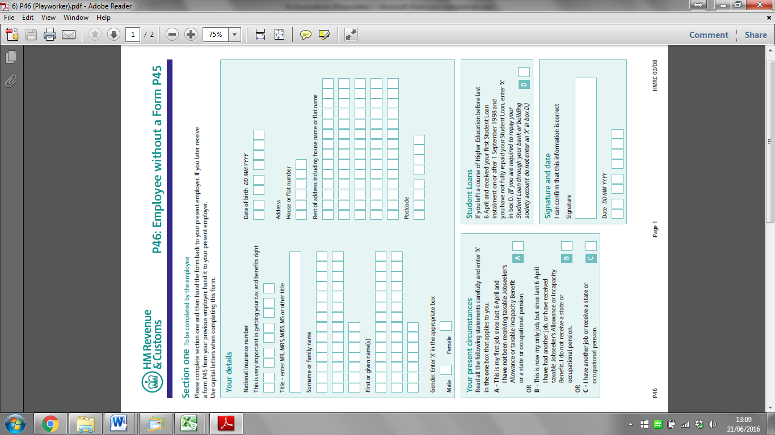

|  |  |
| --- | --- |
| **Your Bank Details:** | |
| **Bank/Building Society Name:** |  |
| **Bank/ Building Society Branch:** |  |
| **Sort Code:** |  |
| **Account Number:** |  |

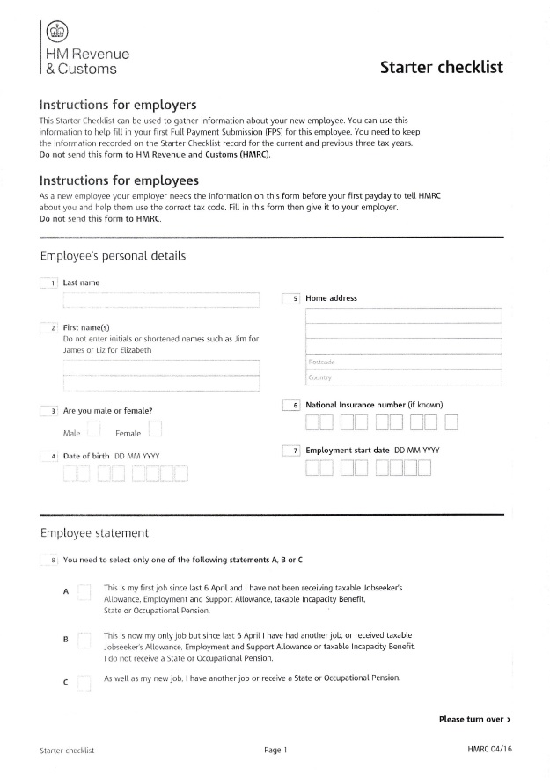

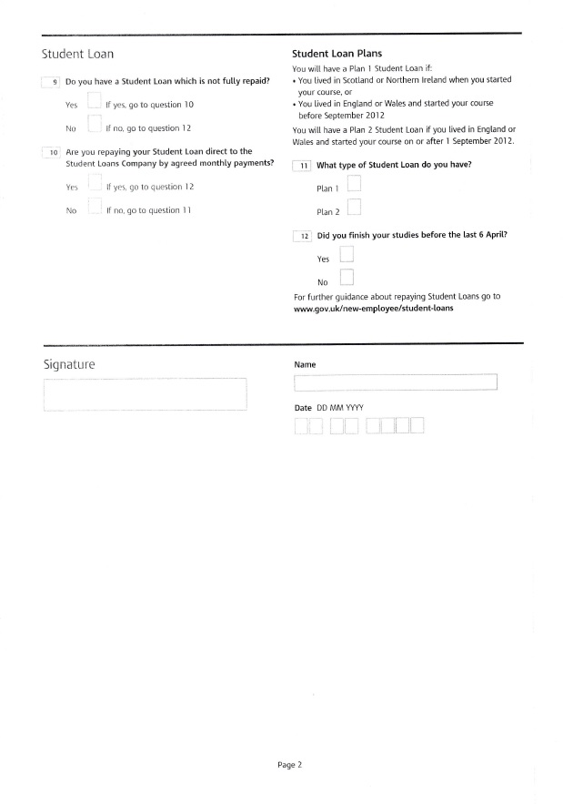



**DBS (Disclosure Barring Service)**

Before you can start working at PACSO, either as staff or a volunteer, you will need to complete an **Enhanced DBS** (if you are over 16). These have to be renewed every 3 years.

**Obtaining a DBS Check**

It is a very easy process and only takes a few minutes to do online.

To login in to the system go to:

<https://disclosure.capitarvs.co.uk/cheqs/rbLogin.do>

Organisation Reference: **PACSO**

Password: **Parents10** (no gaps and a capital P!)

Your position at PACSO is either **Playworke**r or **Volunteer Playworker**.

Make sure you choose **Enhanced DBS** (not Standard).

If you do not have access to a computer, you are very welcome to do it from the office. Please contact the Play Manager to arrange a time to do this.

Once you have completed the online form, the Play Manager will need to verify the check with three forms of ID. Details of the relevant documents can be found at [www.gov.uk/government/publications/basic-check-guidance-and-policies](http://www.gov.uk/government/publications/basic-check-guidance-and-policies). Please text the Play Manager on 07875 601157 to arrange a convenient time to come in and do this.

If you have any problems completing it contact the Play Manager or CRVS on 0870 850 2516.

If you are registered for the **DBS Update Service**, please provide us with your DBS certificate number and confirm the surname and date of birth on the certificate.

Any questions, please contact us.



Registered Charity Number: 1148138

**PLAYWORKER**

**& VOLUNTEER**

**Welcome Pack**

**& Guidelines**



**Welcome to PACSO!**

PACSO is a unique local Charity, serving the Chichester and Arun Districts of West Sussex. We offer fun, play opportunities for children with disabilities and their siblings, to provide much needed short term break provision to them and their families.

PACSO was set up in January 1999 to support parents and carers of children and young people with additional needs. Our respite events aim to work inclusively with children aged between 5 and 19 years and their siblings.

We are really thrilled that you would like to work with us at our clubs. In this booklet we have a few guidelines to help explain what we expect of our Playworkers and Volunteers, and information so you know what to expect of us! We will go over this information in more depth at our Team Meetings. If there is something you do not understand, please ask.

**PACSO Clubs**

**Saturday Clubs** are once a month on a Saturday and offer fun and play for children in Year 1 – age 19. Children can choose from a morning or afternoon session.

**After School Clubs** run weekly during term time offering a wide range of activities!

**Easter & Christmas Play Days** are 2 days in each of the Easter & Christmas holidays offering fun and mayhem, with lots of time for sports, creativity, and our ever popular workshops!

**Trips Out & About** during school holidays give children and young people the chance to visit local attractions and enjoy days out with their PACSO friends.

**Summer Playscheme** is our biggest and most popular event of the year. 2 whole weeks of entertainment, including sports, drama, art, music, and our end of week SHOW!

**Your role at PACSO**

Our aim is to help children and young people grow in self-confidence and self-reliance, within our safe and secure child centred environment. It is important not to direct a child’s play, but follow their lead and imagination.

As a playworker/ volunteer playworker, you are at PACSO to enable children to play. The children at PACSO have a variety of additional needs and require different levels of support. Some children need help physically to join in, encouragement to participate or constant supervision to stay safe. You may be required to work on a one to one basis with some children. If you have any questions about their needs, please just ask us! Most importantly we want you to enjoy yourself! The children will love having your company and the opportunity to play with you!

You will also be expected to help set up and pack away our activities and take part in team time. At team time at the beginning of a session we will inform you of any particular details for that session, and at the end of the session we will have our ‘highs and lows’. This is an opportunity to share with other members of the team your ‘lows’: the things that did not go so well, or that a child struggled with and your ‘highs’: the things that really worked with a child, or some encouraging thoughts. This is a great chance to get things off your chest therefore respecting the need for confidentiality outside of PACSO.

**Communication**

We will text before a club to ask if you can work. Please text back to confirm your availability.

If you cannot make the session for any reason, please let us know as soon as possible by phoning or texting Play Manager Emma on 07875 601157.

**Guidelines for attending PACSO sessions**

* Arrive on time ready for set up or team meeting.
* Sign in on the Staff and Volunteers register.
* Don’t wear dangly earrings and tie your hair back.
* It is your responsibility to ensure that you are wearing the correct PACSO shirt, and are wearing your PACSO badge that has been authorised by a Manager.
* Leave all your possessions in the kitchen, including your mobile phone!
* If you need to leave the hall, please tell your Team Leader or the Play Manager.
* If you need to have a quick break during one of our day sessions, ask your Team Leader. Only one person from a team can go at a time.
* At full day events you will not have a separate lunchbreak so please eat your lunch with the children. If they see you eating they are more likely to eat theirs too!
* Make sure the children are eating from the correct lunch box and only what they came with.
* Remember you are here for PACSO, not to meet up with your friends! Please save your conversations for the end of the session!

**Child Protection, Policies & Procedures**

We must make the children's safety and happiness a priority at all times. If you are worried about a child, please speak to a member of staff straight away.

A full copy of PACSO’s Policies and Procedures is available from the Play Manager, but below is an overview:

**Safeguarding and Child Protection Policy**

Child protection and safeguarding is everyone’s responsibility. If you suspect that any child or young person is at risk, you must tell the Play Manager immediately. Do not go anywhere alone and out of view with a child.

If a child confides in you that they are being abused, you must **not** promise to keep it a secret. You should reassure them by telling them that they have done the right thing by confiding in you. As soon as possible, you should then tell the Play Manager AND go somewhere quiet and write down exactly what the child told you.

**Data Protection Policy**

* Do not disclose any personal information about a child or a family to anyone other than on a ‘need to know’ basis.
* Confidential information relating to every child is contained on the Child Profiles which are kept locked away in the Child Profile box. DO NOT leave Child Profiles out – always put them away after use and make sure the box is locked and left in a secure place.

**Confidentiality Policy**

* If you see/hear anything in the Playroom/ during staff meetings, that is where it stays!

**Risk Assessment Policy**

* If you notice anything you are unsure about, tell the Play Manager.
* Everyone plays a part in maintaining safety.

**Equality and Diversity**

* The PACSO ethos is one of inclusion. Everyone is to be included, regardless of their race, gender, sexual orientation etc.
* Bullying is NOT tolerated at PACSO.
* Do not develop favourite children.
* Be respectful, not judgemental of parents.

**Medication**

* All children’s medication must be given to Nurse/ Play Manager to be locked away.
* Only the Nurse or the trained Play Manager should administer medication.

**Lifting and Handling**

* Because many of the children need to be touched to help them participate, communicate and to be cared for, please be aware that you are touching them and do so with respect and appropriateness.
* Do not lift children if you are unsure how to do it correctly or if you have any injury or condition that prevents you.
* Only use the hoist if you have been trained to use them.
* Do it with someone if you want to learn.
* Ask for help.
* Think ahead.
* Remove hazards.
* Reduce size of loads.
* Mechanise where possible.
* If that’s not possible, carry out a manual handling assessment: task/individual/load/environment

**Toileting Policy**

* Only staff (not volunteers) can toilet.
* Do it in pairs (2nd person can be a volunteer).
* If you are not confident, be the 2nd person.
* Tell the Nurse who needs toileting (there is a form!)
* Use the Nurse or the Play Manager if your team is really hectic!
* Try not to use 2 people from the same team.
* Don’t be scared!
* Playworkers & volunteers should use staff toilets – ensure you go there on your own!

**Complaints Procedure**

* If you are unhappy about something talk to Emma Kennedy (Play Manager)
* If you are unhappy with Emma, talk to Alan Chambers (Operations Manager)
* If you are unhappy with Emma and Alan, talk to Clare Elkington (Chairperson)
* If a parent is unhappy with something, direct them to Emma

**Visitors Policy**

This includes parents, press, etc.

* Be polite at all times
* If you see someone you don’t know, ask them who they are and why they are there.
* You can open the front door, but get the Play Manager or Nurse immediately.
* Direct any visitors or parents to the Play Manager.
* Ask visitors to sign in and give them a visitor’s badge.

**Children’s Possessions and Valuables Policy**

* Children should not bring personal possessions/valuables into PACSO.
* If they do, those possessions should be passed to the Play Manager for safekeeping.
* They should **not** be given to a Playworker or Volunteer – that is not your job!

**Relationships Policy**

* Children are not encouraged to have boyfriend/girlfriend relationships with each other.
* No kissing/cuddling etc at PACSO.
* Get them to join in with everyone and not to go skulking off together!

**Health and Safety – Emergency Procedures**

**What to do in the event of a fire:**

* If you see/smell smoke or see fire press the fire alarm to alert all in the building.
* Only tackle a fire if safe to do so. Do NOT hesitate to call the Fire Brigade. Dial 999.
* At the call of FIRE! You should calmly gather the children in your team.
* Help any children into their wheelchairs and ask able children to push them if necessary.
* Allocated staff will check that all individual rooms and any other areas that children could hide are vacated.
* Staff to evacuate children quickly to point of safety.
* Help all the children to the assembly point.
* The Play Manager will carry out a register.
* Do not re-enter the building until you are told that it is safe to do so.
* Parents are contacted should the children need to be collected.

**What to do in the event of an accident or emergency:**

* If you witness an accident shout HELP!
* Call the First Aiders and the Manager.
* Let the Team Leader, First Aiders and Play Manager deal with the emergency.
* Respond to their requests if you are asked.
* Dial 999 if you need to call Ambulance, Police or Fire Brigade.
* In the event of a child needing to go to hospital the Play Manager will notify the child’s parents or guardians using the information given on the Child Profile form.
* The Play Manager will decide who will accompany the child to hospital. The nurse will give this staff member the child’s Profile Form and any medical information.

## Children not involved in incident/ accident/ emergency:

* Remove all children not involved in the accident or emergency from the room.
* Reassure these children and find something for them to do.
* Send one member of staff to the site of the emergency after 5 minutes to liaise with the Play Manager.
* If the children have witnessed an accident or emergency notify their parents when they are collected.

**Supporting/Supervising Workers**

* If you see another worker acting in a way that could be misinterpreted, speak to the individual and/or the Play Manager.
* Team Meetings – use them to share concerns and identify areas for guidance.
* Support each other on the team
* Have fun – it will encourage the children to have fun too!

If you have any questions about these Policies & Procedures, please speak to the Play Manager.

We hope you will enjoy being part of the PACSO Team!